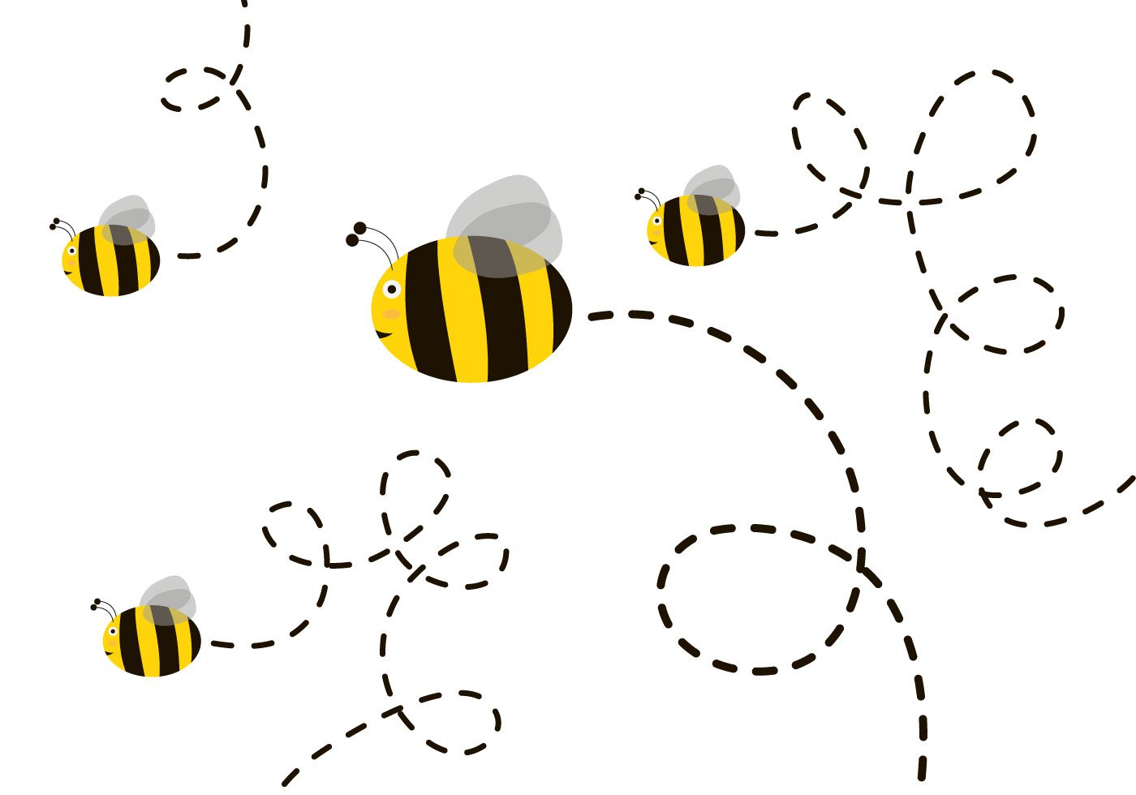

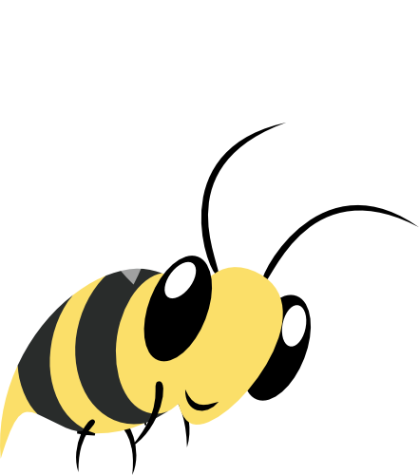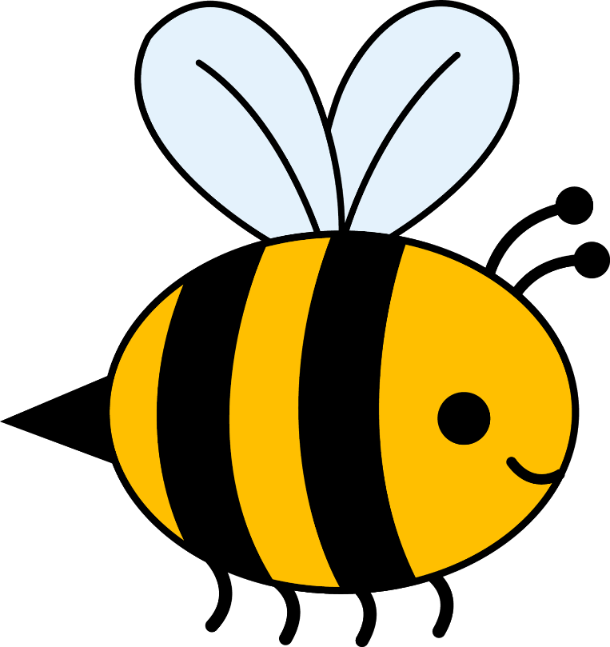

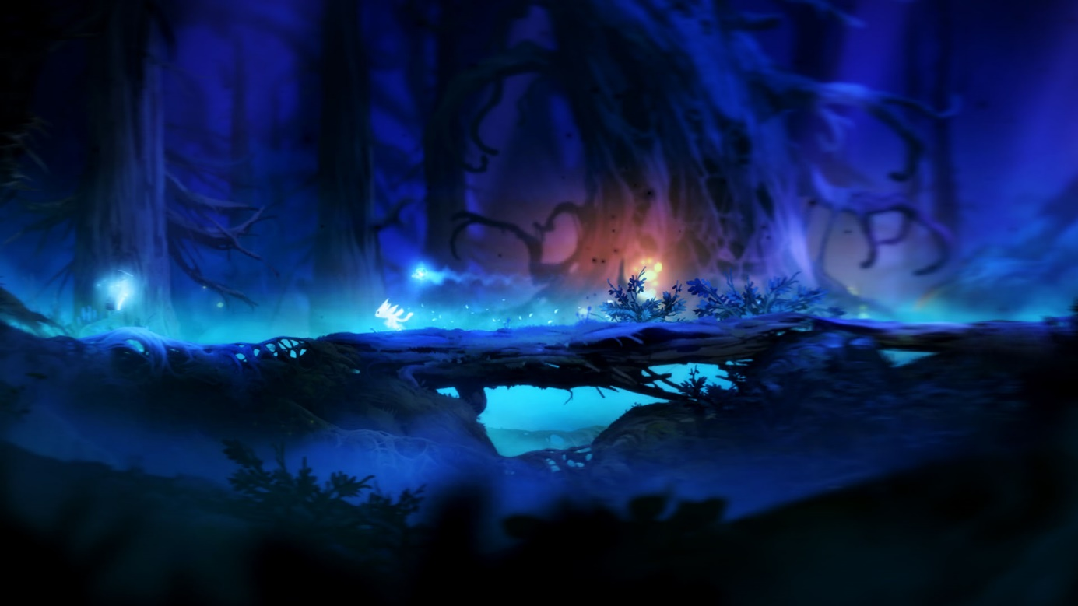

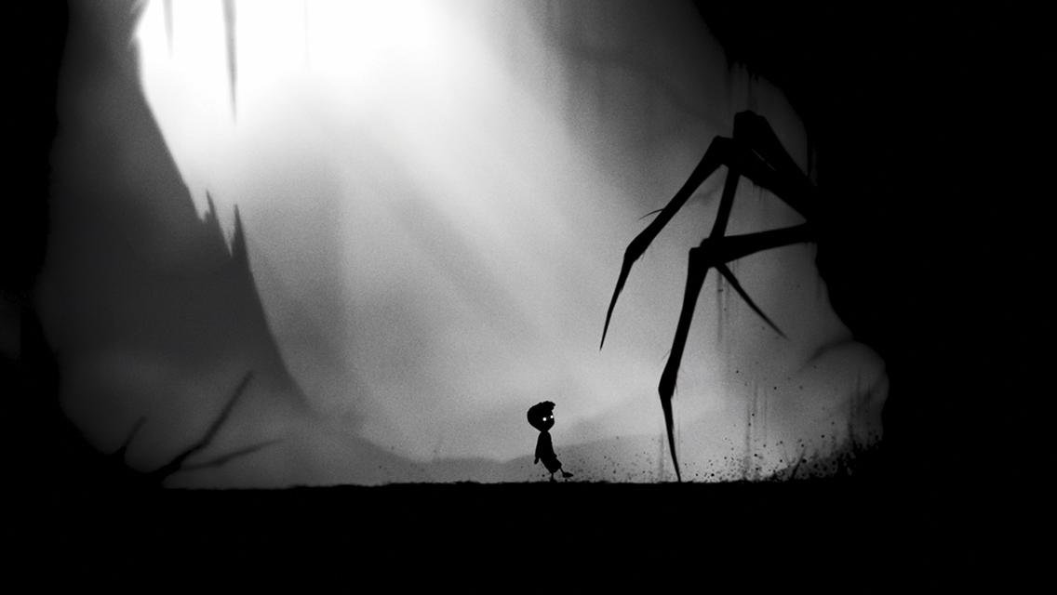

To bee a refugee

Refubee

Doelgroep analyse:

10-12 jaar  
Geen aandacht voor langere tijd.  
Houden van CoD, OW, Minecraft.  
Pokemon GO  
Nintendo.  
Kirby  
Drukke en opvallende beelden.  
Houden van bijen (iedereen houd van bijen).  
Spelen buiten in de natuur.  
Voetballen op straat.

Brainstorm project bee game:

Names:   
Refubee  
Bee alone  
To bee a refugee

|  |  |  |  |
| --- | --- | --- | --- |
| Must | Should | Could | would |
| A bee, bee can walk, jump, fly for 5 seconds | More bee’s in the background | story | Secrets in the levels |
| world | Puzzle elements | More puzzle elements |  |
| stones to pick up |  | powerups |  |
| quests |  | bosses |  |
|  |  |  |  |
|  |  |  |  |
|  |  |  |  |

Bosses: ant colony, spoder, wasp, chameleon

Story:

Tekst: living a normal bee live

1e shot: happy bee

Tekst: until the unexpected happens

2e shot: human silhouet

3e shot: bee hive destroyed

Tekst: a bee must run for his live

4e shot: bee runs away, all the other bee’s are dead

Tekst: will he ever find a home again

5e shot: game screenshot

Tekst: coming this fall

Tekst: or nah